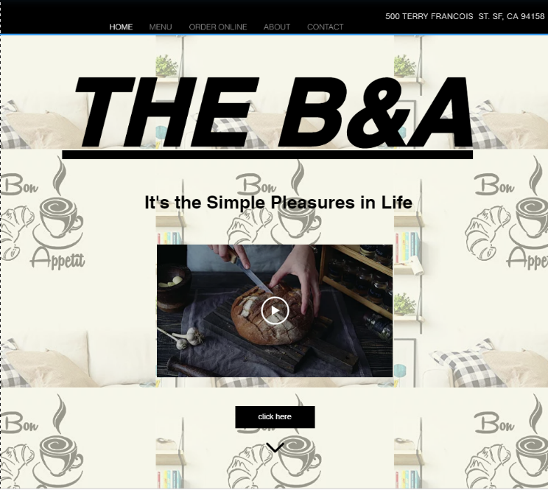

HOME



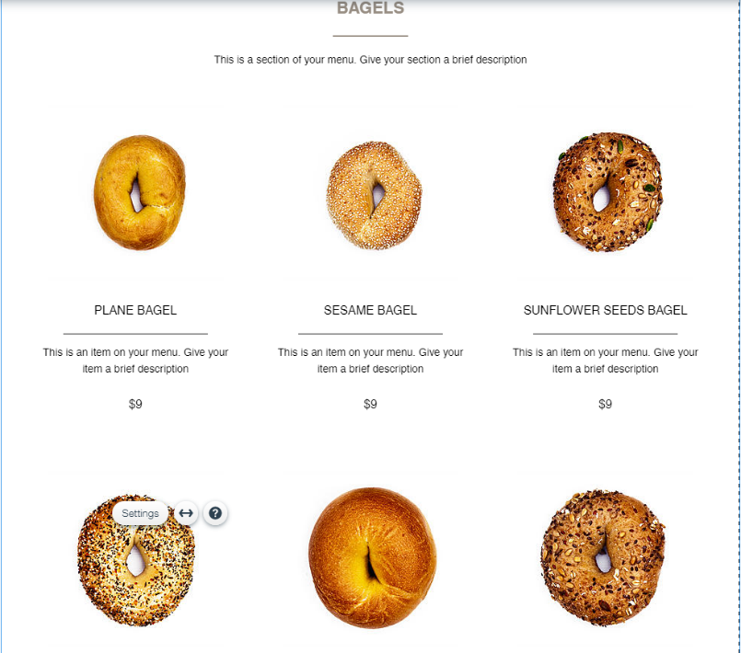

MENU

ONLINE SELLING

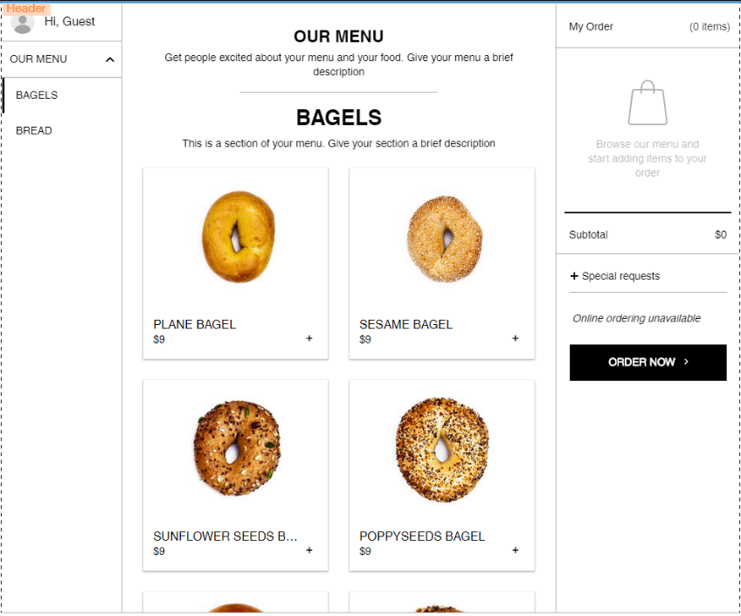

CONTACT

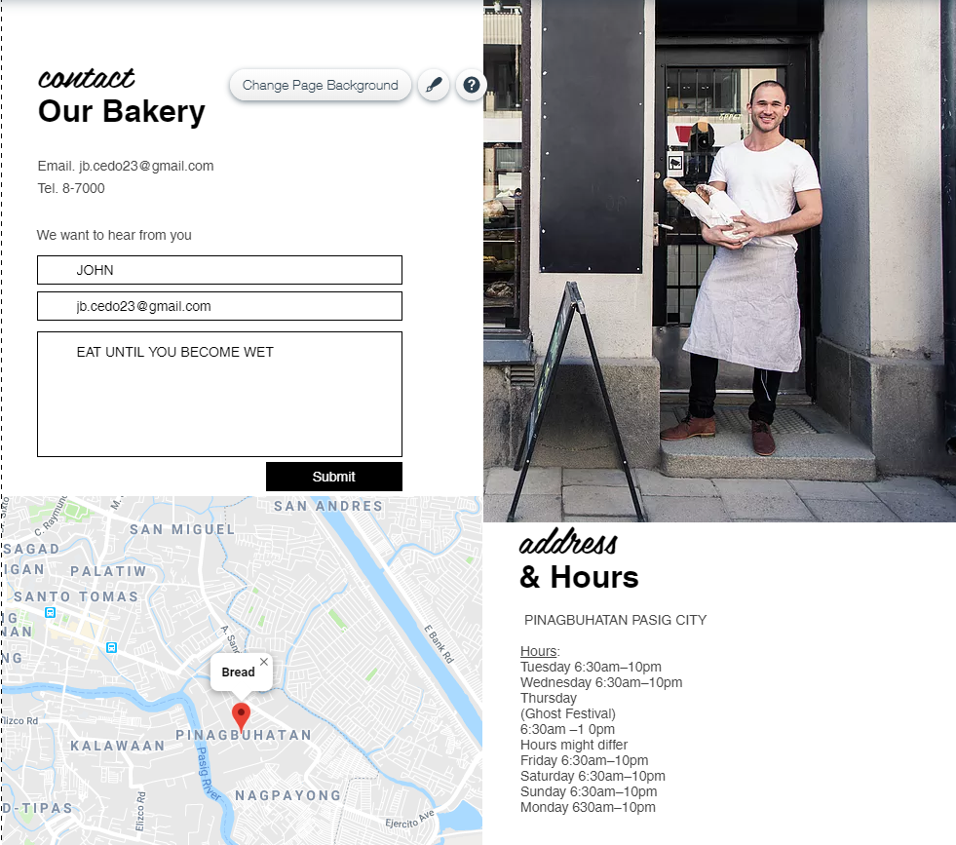

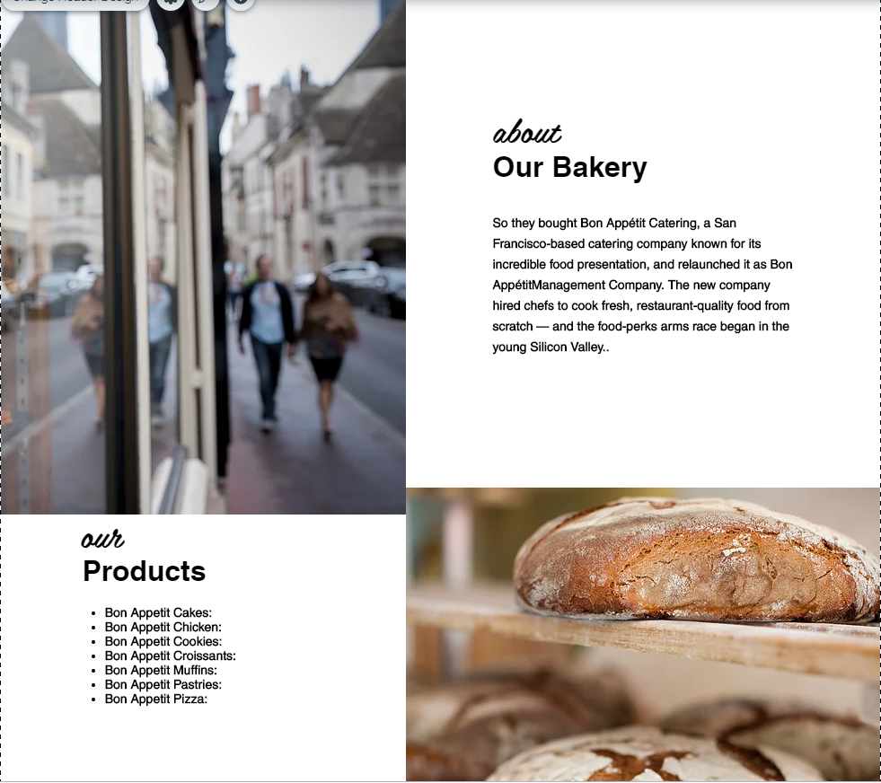

BACKGROUND

This website I made is for all people who wants eat breakfast either snacks. Special for the workers who works in office they need coffee to be more active and alive. For the students that tired of doing their projects or thesis. For the oldies’ who wants peaceful place. This shop can be your comfort zone when your alone maybe because you may know different kind of people. We are easy to find just search our store name “THE B&A” or contact us via Gmail and our telephone no.